Data stuffies

## R Markdown

## mu mean bias pc_bias var mean2_err  
## 1.62 -1.586782 -3.206782 -197.9495 29363.02 29373.3

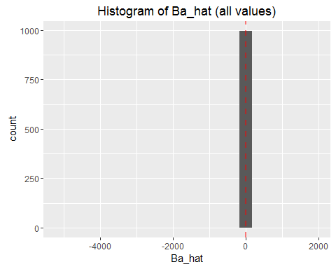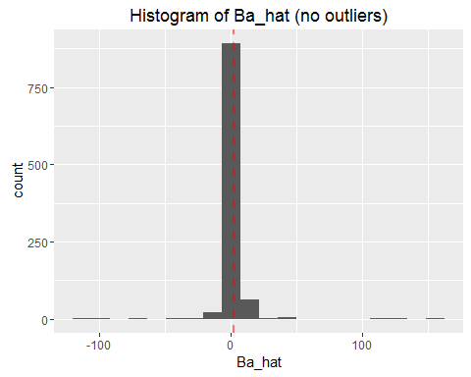

##   
## Beta_0 23234.780  
## Beta_a -5138.577

## V1   
## Min. : -11.00   
## 1st Qu.: -2.69   
## Median : 1.65   
## Mean : 10483.53   
## 3rd Qu.: 3.44   
## Max. :149700.31

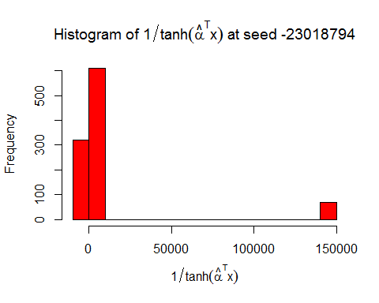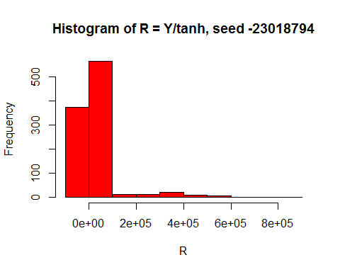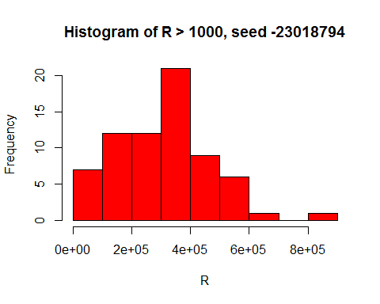

##   
## Beta_0 6456.722  
## Beta_a 1669.734

## V1   
## Min. : -15.77   
## 1st Qu.: -2.79   
## Median : 1.75   
## Mean : 2427.63   
## 3rd Qu.: 3.07   
## Max. :43357.20

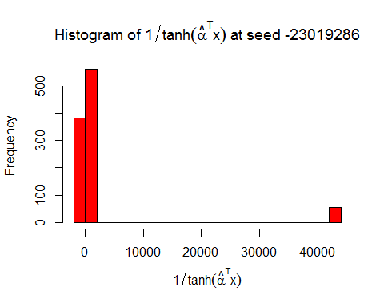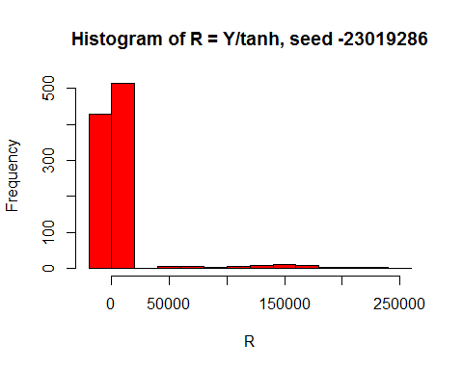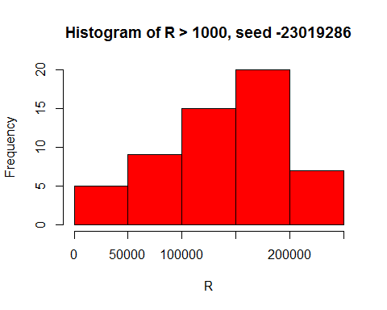

##   
## Beta_0 -2.586358  
## Beta_a 1.684891

## V1   
## Min. :-59.024   
## 1st Qu.: -2.881   
## Median : 1.592   
## Mean : -3.408   
## 3rd Qu.: 3.005   
## Max. : 19.457

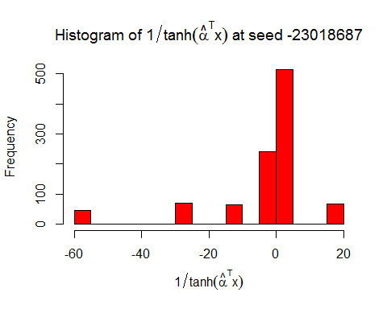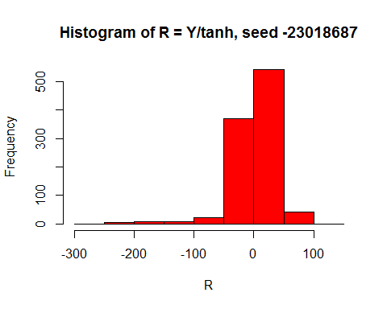

##   
## Beta_0 -6.284415  
## Beta_a 1.571109

## V1   
## Min. :-34.089   
## 1st Qu.: -2.851   
## Median : 1.276   
## Mean : -1.306   
## 3rd Qu.: 2.316   
## Max. : 17.574

